**Q1:** *Which regions and product categories contribute most to overall profit, and which ones are causing losses?*

*Answer:*

Most Profitable: Office Supplies in the West region and Technologies in both East and West regions.

Loss-Making: Furniture in the Central region, with a significant loss of –$2871.

Recommendation: Focus marketing and expansion efforts on profitable segments like Office Supplies (West) and Technologies (East & West), while addressing the loss-making Furniture category through cost control, strategic pricing, or supply chain optimization.

*Explanation:*

In the given data set, the most profitable segment is Office Supplies in the West region, followed by Technologies in East and West.

Recommendation: Focus marketing and expansion strategies on Office Supplies in West and Technology in East and West regions for maximizing revenue.

On the other hand, Furniture in the Central region is facing a loss of –$2871.

This indicates that although the Central region is generally profitable in Technology and Office Supplies, furniture category requires attention for cost control, discount strategy, or supply chain optimization.

Visual Representation:

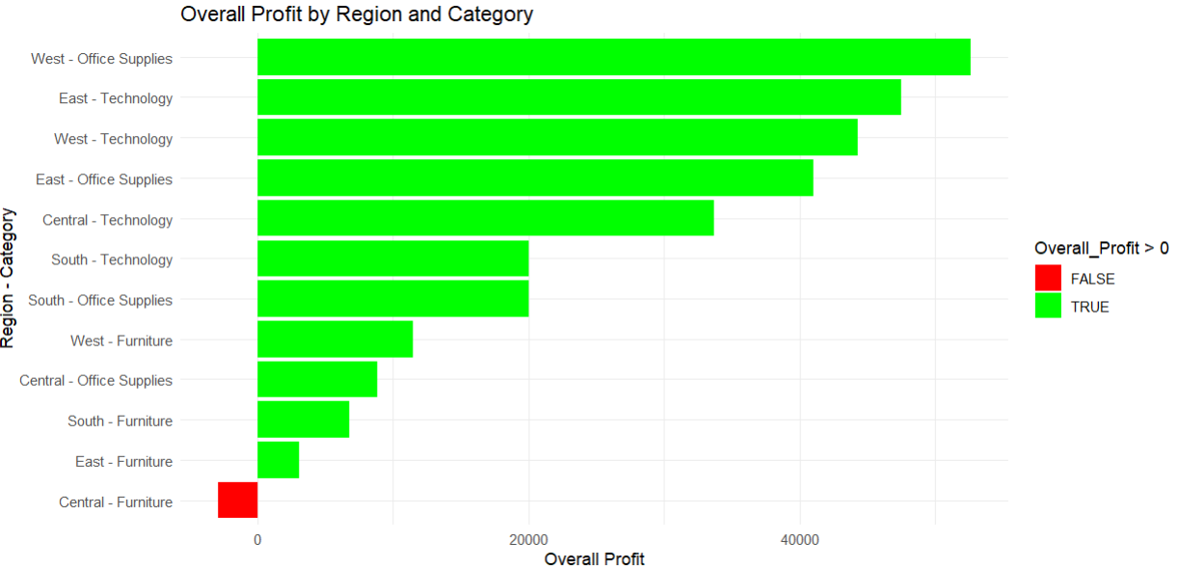

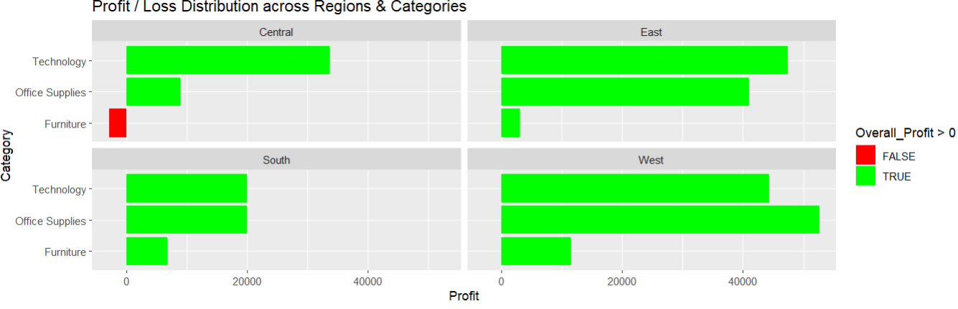

This analysis helps the company to focus on high-performing region-category combinations while addressing loss-making segments through cost control and strategic interventions.

**Q2:** *What are the top 10 underperforming products in terms of profit margin, and what patterns can you observe across their shipping cost, customer segment, or region?*

*Answer:*

Top 10 underperforming products:

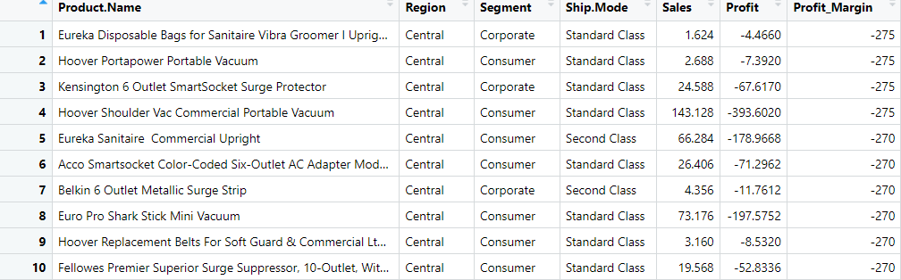

|  |  |  |  |
| --- | --- | --- | --- |
| *Feature* | *Category* | *Count* | *Key Observation* |
| Region | Central | 10 | All underperforming products belong to Central Region. |
|  | East | 0 | — |
|  | South | 0 | — |
|  | West | 0 | — |
| Segment | Consumer | 7 | Majority of loss-making products sold to Consumers. |
|  | Corporate | 3 | Some losses in corporate segment. |
|  | Home Office | 0 | No underperforming products in Home Office segment. |
| Shipping Mode | Standard Class | 8 | Most losses observed in Standard Class shipping. |
|  | Second Class | 2 | Few losses in Second Class shipping. |
|  | First Class | 0 | No losses in First Class shipping. |
|  | Same Day | 0 | No losses in Same Day shipping. |

Visual Representation:

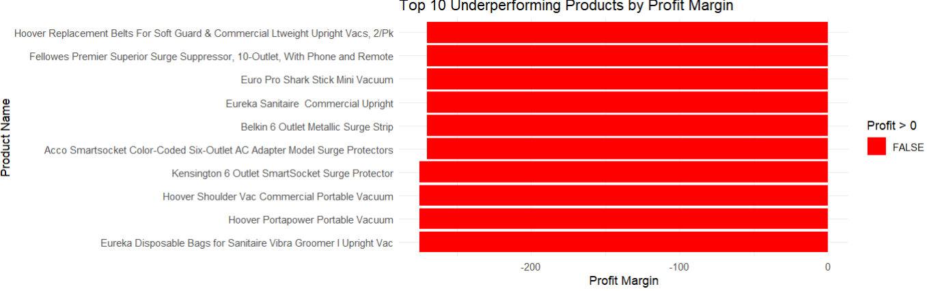

* Key Patterns:
  + Region: Central region dominates in loss-making products.
  + Shipping Mode: Standard Class shipping is common for these products.
  + Customer Segment: Consumer segment shows a high concentration of underperforming products.
* Recommendations:
  + Address regional inefficiencies and high fixed costs.
  + Restrict discounts and focus on higher-margin products.
  + Optimize shipping and delivery costs to minimize losses, especially with Standard Class shipping.
  + Shift focus to less price-sensitive customer segments for higher profitability.

*Explanation:*

Top 10 Underperforming Products (Lowest Profit Margin):

| *Parameter* | *Observation* | *Business Implication* |
| --- | --- | --- |
| Region | All 10 Products from *Central* Region | High concentration of loss-making products — indicates regional profitability risk. |
| Shipping Mode | 8 Products via *Standard Class* | Inefficient shipping cost management; despite cheaper shipping mode, poor cost control observed. |
| Customer Segment | 7 Products to *Consumer* Segment | High price sensitivity; discount-driven sales; negative impact on margins. |

Region Pattern:

* The *Central* region shows clear signs of operational inefficiencies or demand-side issues.
* Possible reasons:
  + High fixed costs. That is, warehouse, staff, rent costs may be high in this region.
  + Aggressive discounts. That is, business is selling products with too much discount to attract customers.
  + Poor customer demand, and inventory management inefficiencies.

Shipping Mode Pattern:

* *Standard Class* is the primary mode for these loss-making products.
* Possible reasons:
  + High return rates. That is, customers buy & return products — business incurs shipping losses.
  + Low order value with high shipping costs. That is, product price is small, but fixed shipping cost hurts profitability.
  + Storage or last-mile inefficiencies. That is, delivery delays, damages, extra handling cost in final delivery steps.

Customer Segment Pattern:

* The *Consumer* segment dominates these low-margin products.
* Possible reasons:
  + High price sensitivity. That is, customers only buy if there is a discount or low price.
  + Discount-driven buying behaviour. That is, business gives heavy discounts to attract sales, but loses money.
  + Low per-order value increasing shipping & handling cost burden. That is, small-sized orders — Shipping cost becomes a bigger burden per product.

**Q3:** *Are there any clear seasonality or trends in sales and profit over time (monthly or quarterly)?*

*Answer:*

Key Observations:

* Sales: Steady growth, with notable seasonal spikes.
* Profit: Although sales are rising, profits remain relatively stagnant, indicating potential inefficiencies in converting sales into profit.
* Recommendation: Investigate operational costs, discount strategies, and pricing models to improve profit margins while sustaining sales growth.

*Monthly Basis (partial output):*

| Month-Year | Total Sales | Total Profit |
| --- | --- | --- |
| Jan-2014 | 14,237 | 2,450 |
| Feb-2014 | 4,520 | 862 |
| Mar-2014 | 55,691 | 499 |
| Apr-2014 | 28,295 | 3,489 |
| May-2014 | 23,648 | 2,739 |
| Jun-2014 | 34,595 | 4,977 |
| Jul-2014 | 33,946 | –841 |
| Aug-2014 | 27,909 | 5,318 |
| Sep-2014 | 81,777 | 8,328 |
| Oct-2014 | 31,453 | 3,448 |

Visual Representation:

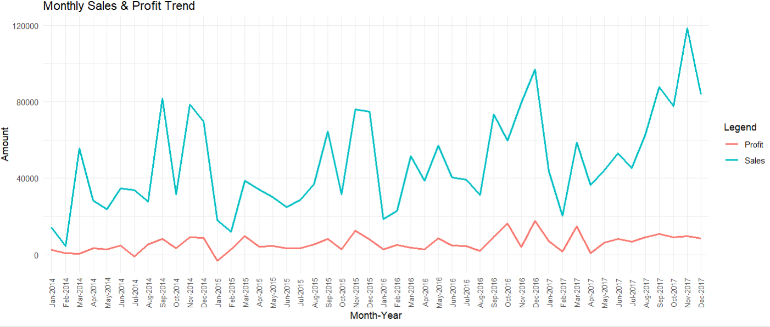

*Explanation:*

Key Observations:

The chart displays the Monthly Sales and Profit Trend for a business from January 2014 to December 2017.

Sales (Blue Line):

Sales exhibit significant fluctuations over time, with noticeable peaks and valleys. There is a general upward trend in sales, especially from 2016 onward, indicating growth in revenue. The highest sales value is observed around late 2017.

Profit (Red Line):

Profit remains relatively low compared to sales throughout the period. Although profits also show fluctuations, they are less pronounced than sales. here is no clear upward trend in profits, suggesting that while sales are increasing, profitability may not be improving proportionally.

Seasonality:

Both sales and profit seem to follow a seasonal pattern, with spikes occurring at regular intervals, possibly indicating higher activity during specific months (e.g., holiday seasons or end-of-year periods).

Sales vs. Profit Relationship:

Despite rising sales, profits remain consistently low, which could indicate high operational costs, discounts, or other factors affecting profitability.

Insights:

The business is growing in terms of revenue but may need to focus on improving profit margins.

This chart highlights the importance of balancing revenue growth with profitability for sustainable business success.

*Quarterly Basis:*

|  |  |  |  |
| --- | --- | --- | --- |
| Quarter_Year | Quarter_Num_Int | Total_Sales | Total_Profit |
| Q1-2014 | 1 | 74448 | 3811 |
| Q2-2014 | 2 | 86539 | 11204 |
| Q3-2014 | 3 | 143633 | 12805 |
| Q4-2014 | 4 | 179628 | 21724 |
| Q1-2015 | 5 | 68852 | 9265 |
| Q2-2015 | 6 | 89124 | 12191 |
| Q3-2015 | 7 | 130260 | 16854 |
| Q4-2015 | 8 | 182297 | 23309 |
| Q1-2016 | 9 | 93237 | 11441 |
| Q2-2016 | 10 | 136082 | 16390 |
| Q3-2016 | 11 | 143787 | 15824 |
| Q4-2016 | 12 | 236099 | 38140 |
| Q1-2017 | 13 | 123145 | 23506 |
| Q2-2017 | 14 | 133764 | 15499 |
| Q3-2017 | 15 | 196252 | 26985 |
| Q4-2017 | 16 | 280054 | 27449 |

Visual Representation:

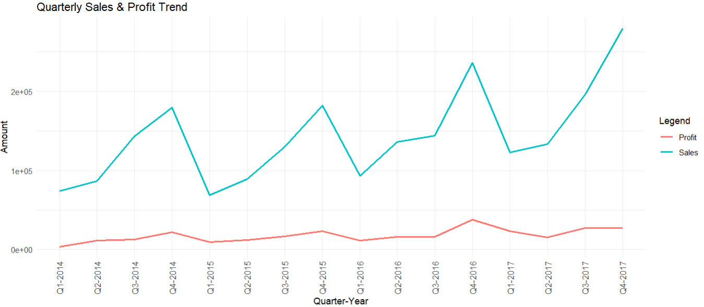

Key Observations:

Sales Trend (Cyan Line) seasonality:

Sales show a cyclical pattern, with peaks and troughs occurring periodically. There is an overall upward trend in sales over the years, with Q4-2017 showing the highest sales amount. Seasonal spikes are noticeable, indicating highest sales in fourth quarter of each year, followed by a sharp drop in the first quarter of the next year, and a gradual rise thereafter.

Profit Trend (Red Line) seasonality:

Profits remain relatively flat compared to sales, with minor fluctuations. The profit values are significantly lower than sales throughout the period. While there is some growth in profits over time, it is quite negligible.

Disparity Between Sales and Profit:

The gap between sales and profit is substantial, suggesting high costs or low-profit margins despite increasing sales. Even during periods of peak sales, profits do not show a corresponding sharp increase.

Insights:

The company may need to investigate cost structures or pricing strategies to improve profitability. The seasonal nature of sales could be leveraged for better inventory and marketing planning. Despite growing sales, the relatively stagnant profit trend may indicate inefficiencies or challenges in converting revenue into profit.

This chart highlights the need for strategic focus on profitability while sustaining sales growth.

Optional task:

*Explanation of the Heatmap:*

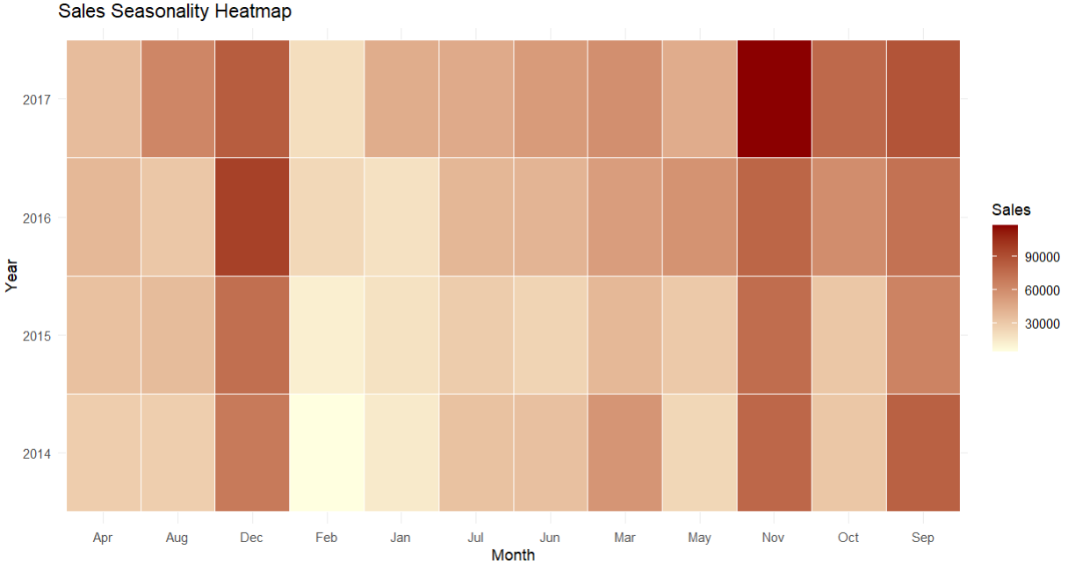

This is a *Sales Seasonality Heatmap*.

* It shows *monthly sales* patterns from 2014 to 2017.
* The *x-axis* represents the months (Jan to Dec).
* The *y-axis* represents the years (2014 to 2017).
* The *colour* shows the sales amount:
  + Light colour = Low Sales
  + Dark colour = High Sales

Key Insights:

* Sales are highest in *November* (2017) — very dark colour.
* *December* and *September* also show high sales every year.
* *February* has the lowest sales — very light colour.
* Sales are generally better in the second half of the year (Aug to Dec).

Conclusion:

This heatmap helps identify:

* Best sales months → *Nov, Dec, Sep*
* Slow sales months → *Feb, Jan*
* Seasonal sales trends over the years.

Explanation of year-on-year growth:

|  |  |  |  |
| --- | --- | --- | --- |
| Year | Total Sales | Total Profit | Sales YoY Growth (%) |
| 2014 | 4,84,247 | 49,544 | NA |
| 2015 | 4,70,533 | 61,619 | –2.83 |
| 2016 | 6,09,206 | 81,795 | 29.5 |
| 2017 | 7,33,215 | 93,439 | 20.4 |

* In 2014, sales were ₹4.84 lakh and profit was ₹49k.
* In 2015, sales dropped slightly by 2.83%, but profit increased to ₹61k.
* In 2016, sales grew strongly by 29.5%, profit also increased to ₹81k.
* In 2017, sales further grew by 20.4%, and profit reached ₹93k.

Sales and Profit both increased well after 2015. The business is showing good growth from 2016 onwards.

**Q4:** *Which states or cities show high sales but low profits, and what corrective actions might be suggested based on the analysis?*

*Answer:*

* *States with Negative Sale-Profit Ratios:*
  + *Illinois, Texas, Colorado, Pennsylvania, Ohio.*
  + *Recommendations: Reassess discount policies, optimize supply chain costs, focus on promoting high-margin products, and better align regional marketing campaigns to customer behaviour.*
* *Cities with Negative Sale-Profit Ratios:*
  + *Abilene, Romeoville, Deer Park, Missouri City, Littleton.*
  + *Recommendations: Analyse pricing strategies, restrict discounts on non-profitable products, improve logistics and delivery costs, and target profitable customer segments with tailored loyalty programs.*

*Explanation:*

For states:

|  |  |  |
| --- | --- | --- |
| State | Avg_Sale_Profit_Ratio | KPI_Status |
| Illinois | –0.392 | Loss |
| Texas | –0.342 | Loss |
| Colorado | –0.124 | Loss |
| Pennsylvania | –0.0861 | Loss |
| Ohio | –0.0741 | Loss |

Visual Representation:

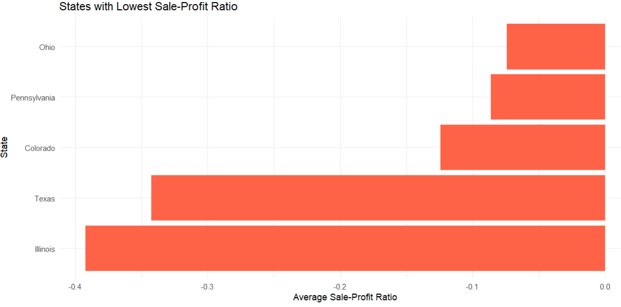

Interpretation:

A negative “Sale_Profit_Ratio” means the company is facing losses (Profit < 0) despite sales.

Possible Reasons:

* High Discounting practices → Cutting too much into profit margins
* Higher Shipping or Operating Costs in these states
* Poor Inventory Management → Overstocking or obsolescence
* Unprofitable Product Mix → Selling low-margin products
* Inefficient Supply Chain in these regions
* Regional Competition forcing aggressive pricing

Recommended Corrective Actions:

* Discount Strategy : Reassess discount policies in these states. Apply targeted discounts only on slow-moving products. Avoid blanket discounting.
* Product Portfolio : Perform product-wise profit analysis → Identify and phase out unprofitable products. Promote high-margin products.
* Operational Costs : Analyse supply chain costs (logistics, warehousing). Optimize routes or suppliers to reduce overhead
* Regional Marketing : Conduct market research in these states to understand customer behaviour and price sensitivity. Modify campaigns accordingly.
* Pricing Strategy : Consider revising the pricing model or bundling products for better profitability.

Illinois and Texas are major concern areas with a significantly negative Sale-Profit Ratio.

Immediate corrective actions are recommended to control discounting practices, reassess product strategies, and optimize operational costs in these states.

*For cities:*

|  |  |  |
| --- | --- | --- |
| City | Avg_Sale_Profit_Ratio | KPI_Status |
| Abilene | –2.7 | Loss |
| Romeoville | –1.65 | Loss |
| Deer Park | –1.5 | Loss |
| Missouri City | –1.5 | Loss |
| Littleton | –1.37 | Loss |

Visual Representation:

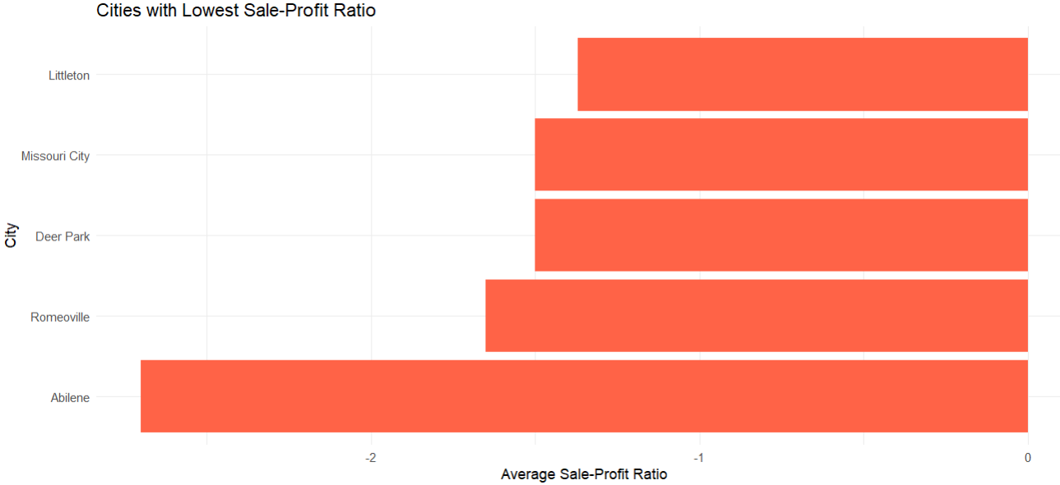

Interpretation:

The bottom 5 cities — Abilene, Romeoville, Deer Park, Missouri City, Littleton — have very poor “Sale_Profit_Ratio”, indicating these cities are incurring heavy losses relative to sales.

Especially Abilene with –2.7 means for every 1 unit of sales, the company is losing 2.7 units — a critical situation!"

Possible Reasons for Low “Sale_Profit_Ratio”:

* Heavy Discounts or Promotions : Aggressive discounting to boost sales leading to losses.
* High Operational Costs : Shipping cost, warehouse cost, or delivery inefficiencies in those cities.
* Product Returns : Higher product return rates affecting profitability.
* Wrong Product Mix : Selling low-margin or loss-making products.
* Low Customer Lifetime Value : One-time buyers with minimal repeat purchases.

Suggested Corrective Actions:

* Conduct pricing analysis specific to these cities.
* Optimize or restrict discounts on non-profitable products.
* Implement minimum profit margin thresholds.
* Optimize Logistics & Delivery Costs
* Audit shipping costs for these cities.
* Explore cheaper logistics partners.
* Consider regional warehouses for cost efficiency.
* Analyse which product categories are dragging down profits.
* Focus on promoting high-margin products.
* Consider discontinuing consistently loss-making products.
* Identify high-value customer segments in these cities.
* Targeted loyalty programs or exclusive deals for profitable segments.
* Personalized marketing instead of mass discounts.
* Investigate operational bottlenecks.
* Streamline supply chain for these regions.
* Analyse inventory holding costs.

*Optional task:*

The correlation between Discount and Profit is –0.2194875, with a very small p-value.

Therefore, there is sufficient statistical evidence to conclude that there is a significant negative correlation between Discount and Profit.

This implies that products with higher discounts are more likely to generate lower profit.

Key Insights and Recommendations:

1. Focus on profitable regions and categories (Office Supplies, Technologies).
2. Address loss-making regions and categories (Furniture in Central, underperforming products in the Central region).
3. Optimize cost structures, particularly shipping and operational costs, to improve profitability.
4. Refine customer segmentation to focus on less price-sensitive segments, ensuring higher profit margins.
5. Investigate operational inefficiencies, especially in cities with negative Sale-Profit Ratios, and implement corrective actions based on region-specific insights.

By focusing on these strategies, the company can maximize profitability while ensuring sustainable growth in both sales and profits.